CORE SYSTEMS

Section Header
The Systems That Power Continuous Intelligence and Execution
Subtext
MonkDB is not a collection of features—it is a set of deeply integrated systems that unify data, intelligence, and execution into a single continuous architecture.

1. Unified Operational Engine

Menu Line
One system. All data. One operational truth.

Headline
The Foundation of Unified, Real-Time Operations

Overview
The Unified Operational Engine consolidates all data types, workloads, and operational states into a single system—eliminating fragmentation across the enterprise.

Explore More (Deep Content)
Enterprises today operate across fragmented systems—OLAP stores, vector databases, streaming engines, document stores—each maintaining its own version of reality. This leads to inconsistencies, duplication, and delayed coordination.
The Unified Operational Engine addresses this by creating a single operational fabric where:

Multi-Model Data Convergence
Structured, semi-structured, unstructured, time-series, geospatial, and vector data coexist in a single engine—eliminating the need for multiple specialized systems.

Single Source of Operational Truth
All data is ingested, stored, and queried within the same system—ensuring consistent, real-time state across applications and workflows.

In-Place Processing
Data is processed where it resides. No duplication. No movement. No synchronization lag.

Cross-Domain Correlation
Combine transactional signals, behavioural data, and contextual intelligence in real time—enabling richer and more accurate decision-making.

Operational Simplicity
Replace fragmented architectures with a unified system—reducing infrastructure complexity, integration overhead, and operational risk.

2. Real-Time Processing Engine

Menu Line
Continuous processing. No batches. No waiting.

Headline
A System That Never Stops Processing

Overview
The Real-Time Processing Engine enables continuous ingestion, transformation, and querying of data—ensuring that every signal is processed the moment it arrives.

Explore More (Deep Content)
Traditional systems rely on batch cycles or micro-batch approximations of real-time, introducing delays and inconsistencies. MonkDB is designed as a true streaming-first system.

Continuous Data Ingestion
Streams, events, logs, transactions, and sensor data are ingested continuously—without buffering or staging layers.

Instant Processing & Querying
Every incoming data point is immediately available for querying, aggregation, and analysis—no waiting for pipeline completion.

Always-Live State Management
System state is continuously updated with every event, ensuring that all queries reflect the most current reality.

Unified Streaming + Analytical Processing
Eliminates the need for separate streaming and analytical systems—both operate within a single engine.

Low-Latency Execution at Scale
Designed for high throughput and concurrency, enabling real-time decision-making even under heavy workloads.

3. AI-Native Execution Engine

Menu Line
AI inside the system. Not outside.

Headline
Intelligence Embedded Into the Core of Data

Overview
The AI-Native Execution Engine integrates intelligence directly into the data layer—allowing systems to continuously learn, reason, and act on live data.

Explore More (Deep Content)
In most architectures, AI is an external layer that depends on data pipelines and periodic updates. This results in stale models and disconnected intelligence.
MonkDB redefines this by embedding AI natively:

Native Vector + Hybrid Query Engine
Perform semantic search, similarity matching, and contextual reasoning alongside traditional SQL queries—within the same execution path.

Live Contextual Intelligence
AI operates on continuously updated data, ensuring that decisions are always based on current system state.

Stateful Intelligence
Maintain context over time—enabling systems to understand sequences, patterns, and evolving conditions.

In-Place Inference and Decisioning
Run AI logic directly within the system—without exporting data to external services.

Unified Data + AI Layer
Eliminate the gap between data storage and intelligence—creating a tightly coupled, high-performance system.

4. Decision Action Engine

Menu Line
Decide and execute—without delay.

Headline
From Insight to Action—Instantly

Overview
The Decision Action Engine transforms intelligence into immediate execution—enabling systems to act the moment a condition is met.

Explore More (Deep Content)
Most enterprise systems generate insights but rely on external workflows, manual processes, or delayed integrations to act. This creates a critical gap between decision and execution.
The Decision Action Engine closes this gap:

Event-Driven Decisioning
Trigger decisions based on real-time events, thresholds, or patterns detected in data streams.

Rule-Based + AI-Driven Actions
Combine deterministic logic with AI-driven insights to drive precise and adaptive execution.

Instant State Transitions
Update system states immediately—ensuring downstream processes operate on the latest outcomes.

Embedded Execution Logic
Execute actions directly within the platform—without relying on external orchestration tools.

Autonomous Operations
Enable systems to operate with minimal human intervention—continuously sensing, deciding, and acting.

5. Edge to Cloud Execution Fabric

Menu Line
Distributed intelligence. Unified control.

Headline
One Execution Layer Across Every Environment

Overview
The Edge-to-Cloud Execution Fabric connects distributed systems into a single, synchronized execution environment—spanning edge devices, on-prem systems, and cloud platforms.

Explore More (Deep Content)
Modern enterprises operate across highly distributed environments, but intelligence and execution are often centralized—creating latency and dependency.
This fabric enables truly distributed systems:

Edge Intelligence & Execution
Process and act on data locally at the source—reducing latency and bandwidth usage.

Cloud Coordination & Aggregation
Central systems maintain global visibility, coordination, and optimization across all nodes.

Seamless Synchronization
Maintain consistency between edge and cloud environments—ensuring unified system state.

Resilience & Offline Capability
Continue operations even in disconnected environments, syncing when connectivity is restored.

Scalable Distributed Architecture
Expand across geographies and environments without compromising performance or control.

6. Sovereignty & Trust Layer

Menu Line
Built for control, compliance, and confidence.

Headline
Trust and Control at the Core of Intelligence

Overview
The Sovereignty & Trust Layer ensures that data, intelligence, and execution remain secure, governed, and fully under enterprise control.

Explore More (Deep Content)
As organizations adopt AI-driven systems, concerns around data security, compliance, and control become critical. MonkDB addresses these at the architectural level.

Data Sovereignty by Design
Keep data within your chosen environment—cloud, on-prem, or edge—without forced movement or external dependency.

Granular Access Control
Implement fine-grained role-based access across data, queries, and execution layers.

Secure Execution Environment
Ensure that all processing and decisioning occurs within controlled and trusted boundaries.

Auditability & Traceability
Track data access, transformations, and decisions—ensuring full transparency and compliance.

Regulatory Alignment
Support enterprise and regulatory requirements for data governance, privacy, and security.

FINAL CLOSING (FOR THIS SECTION)
MonkDB Core Systems form a continuous execution architecture—where data, intelligence, and action operate as one unified system in real time.
We require a diagram as below depicting all the core engines
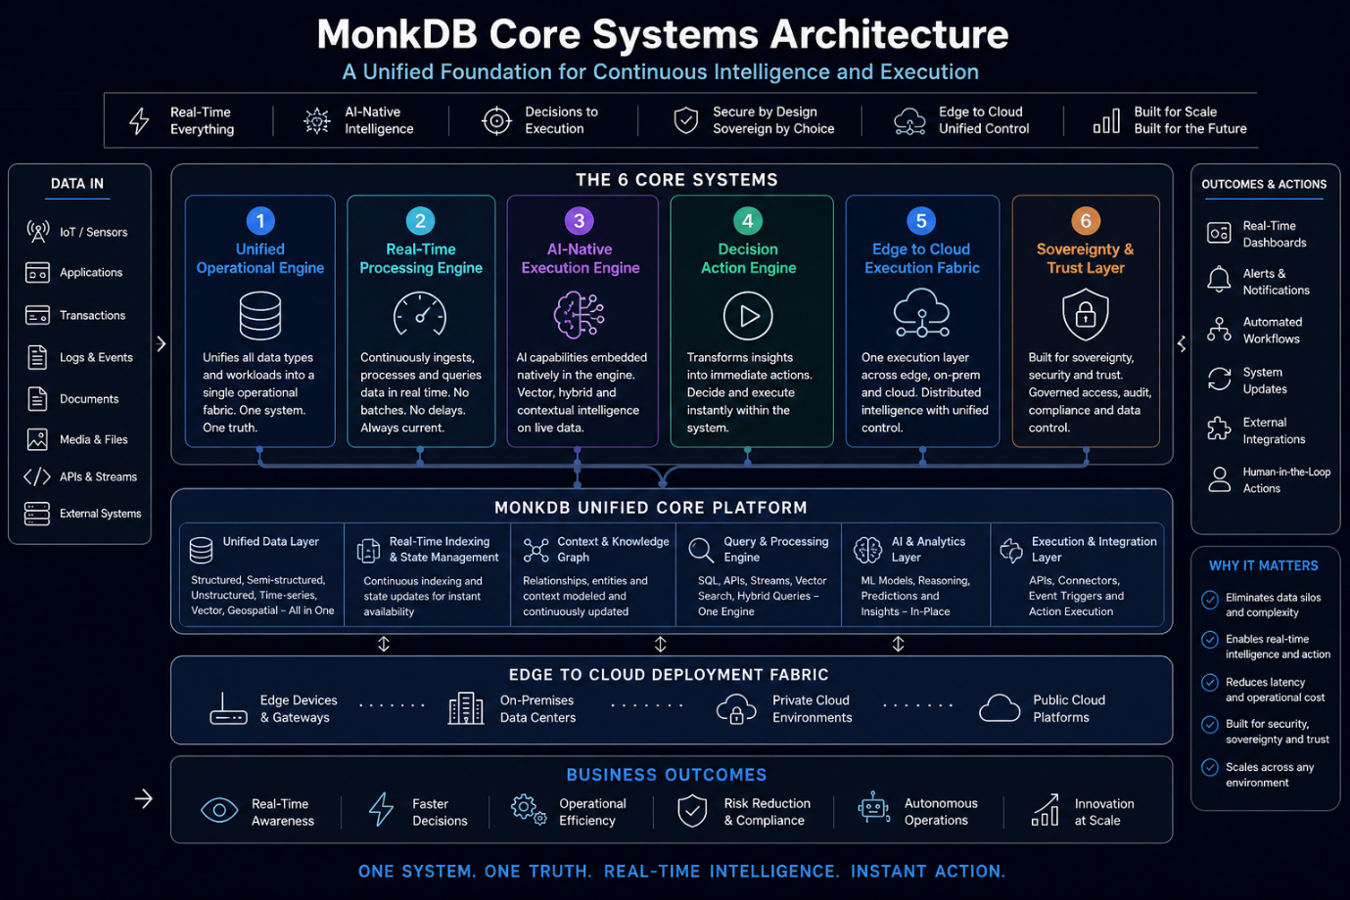

SOLUTIONS

🔻 AI/ML
Crisp Line
Build, run, and scale AI on live data.
Overview
Enable end-to-end AI systems that operate directly on real-time and historical data within a unified platform.
Explore More
Most AI systems depend on disconnected pipelines and static datasets, leading to outdated models and delayed decisions. MonkDB enables AI to operate directly on live data:
- Train and infer on continuously updated datasets
- Combine structured + unstructured + vector data seamlessly
- Deploy models without external data movement
- Maintain real-time context for accurate predictions
This transforms AI from offline models → continuous intelligence systems.

Real-Time Streaming
Crisp Line
Ingest, process, and act—instantly.
Overview
Process high-velocity streams of data in real time and convert signals into immediate action.
Explore More
Streaming systems often require separate ingestion, processing, and analytics layers. MonkDB unifies this:
- Continuous ingestion of events, logs, and signals
- Instant querying and aggregation on incoming streams
- Real-time detection of patterns and anomalies
- Immediate triggering of actions
From data flow to decision in one continuous system.

🔻 Iceberg Tables
Crisp Line
Open, scalable, and high-performance data lake architecture.
Overview
Enable modern data lakehouse capabilities with efficient storage, versioning, and query performance.
Explore More
Iceberg tables bring structure and reliability to large-scale data lakes. MonkDB enhances this with:
- Efficient handling of large analytical datasets
- Schema evolution and version control
- High-performance querying across massive data volumes
- Seamless integration with real-time data
This enables lakehouse performance without complexity.

Real-Time Operational Intelligence
Crisp Line
Know what’s happening. Act immediately.
Overview
Transform live data into continuous operational awareness and decision-making.
Explore More
Traditional BI systems provide historical insights, not real-time intelligence. MonkDB enables:
- Continuous monitoring of operations
- Live dashboards backed by real-time data
- Instant detection of deviations and inefficiencies
- Automated responses to operational events
Shift from reporting → real-time operational control.

Autonomous Decisioning Systems
Crisp Line
Systems that decide and act—on their own.
Overview
Build intelligent systems that can continuously sense, decide, and execute without manual intervention.
Explore More
Autonomous systems require real-time data, intelligence, and execution tightly coupled. MonkDB provides:
- Event-driven decision frameworks
- AI + rule-based decisioning
- Instant execution of actions
- Continuous learning from outcomes
This enables self-operating, adaptive systems.

Energy and Resource Optimization
Crisp Line
Optimize usage. Reduce waste. Improve efficiency.
Overview
Use real-time data and AI to optimize energy consumption and resource utilization.
Explore More
Energy systems often operate inefficiently due to delayed insights. MonkDB enables:
- Real-time monitoring of energy usage
- Predictive optimization models
- Dynamic control of resources
- Continuous efficiency improvements
Delivering lower costs + sustainable operations.

Digital Twin and Simulation
Crisp Line
Mirror reality. Predict outcomes. Act faster.
Overview
Create real-time digital replicas of systems to simulate, predict, and optimize operations.
Explore More
Digital twins require continuous synchronization and intelligence. MonkDB enables:
- Real-time data synchronization from physical systems
- Continuous state updates
- Predictive simulation models
- Immediate execution based on simulated outcomes
From visibility → predictive and autonomous operations.

Edge Intelligence and Distributed AI
Crisp Line
Intelligence where data is generated.
Overview
Run AI and processing at the edge while maintaining centralized coordination.
Explore More
Centralized AI creates latency and dependency. MonkDB enables distributed intelligence:
- Local data processing at edge devices
- Real-time decision-making without cloud dependency
- Synchronization with central systems
- Resilient operations in low-connectivity environments
This enables true edge-native intelligence systems.

Data and AI Modernization
Crisp Line
Replace legacy stacks with one unified platform.
Overview
Modernize fragmented data and AI architectures into a single, real-time execution system.
Explore More
Legacy architectures are complex, costly, and slow. MonkDB enables:
- Consolidation of multiple systems into one
- Elimination of pipelines and redundant layers
- Real-time processing and AI integration
- Faster deployment and lower operational overhead
Move from stitched architecture → unified execution platform.

AI Governance and Trust
Crisp Line
Control, compliance, and confidence in AI.
Overview
Ensure AI systems operate securely, transparently, and within defined governance frameworks.
Explore More
AI adoption brings challenges in trust and compliance. MonkDB addresses this with:
- Fine-grained access control
- Data and model governance
- Full auditability of decisions
- Secure and sovereign data handling
Ensuring AI systems are trusted, compliant, and enterprise-ready.

OUTCOMES (Refined for Impact)
You can keep these short, but here’s slightly stronger wording:
- Reduce Cost → Eliminate infrastructure sprawl and operational overhead
- Improve Efficiency → Optimize operations with real-time intelligence
- Enhance Safety → Detect risks early and act instantly
- Enable Autonomy → Power self-operating intelligent systems
- Ensure Trust & Compliance → Govern data and AI with confidence
- Accelerate Decision-Making → Move from insight to action in real time

FINAL LINE (OPTIONAL ADD)
From Use Cases to Outcomes—MonkDB turns real-time data into real-world impact.

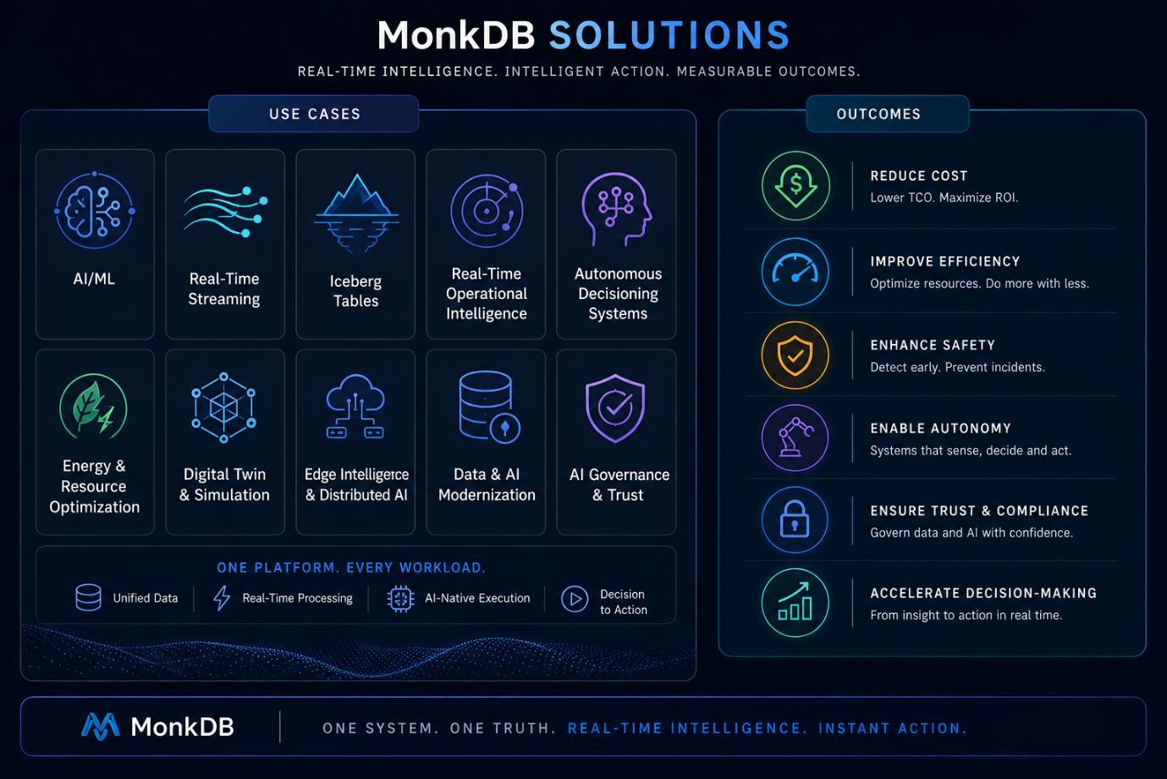

INDUSTRIES

Mining and Manufacturing
Crisp Line
Real-time control for complex, asset-heavy operations.
Overview
Unify operational, sensor, and environmental data to drive intelligent, real-time decision-making across mining and manufacturing ecosystems.
Explore More
Mining and manufacturing environments generate continuous streams of data from equipment, sensors, and operations. MonkDB enables:
- Real-time monitoring of equipment and conditions
- Ventilation-on-demand and safety optimization
- Predictive maintenance and failure prevention
- Continuous process optimization
This transforms operations from reactive to predictive and autonomous.

Automobiles
Crisp Line
Connected, intelligent, and adaptive mobility systems.
Overview
Enable real-time intelligence across vehicles, fleets, and mobility ecosystems.
Explore More
Automotive systems require seamless integration of telemetry, user behavior, and environmental data. MonkDB enables:
- Connected vehicle intelligence
- Fleet optimization and dynamic routing
- Real-time diagnostics and predictive maintenance
- Integration with smart city infrastructure
Driving smarter, safer, and more responsive mobility systems.

BFSI and Capital Markets
Crisp Line
Low-latency intelligence for high-stakes decisions.
Overview
Process financial data in real time to enable risk management, fraud detection, and intelligent trading.
Explore More
Financial systems demand speed, accuracy, and compliance. MonkDB enables:
- Real-time fraud detection and prevention
- Risk scoring and compliance monitoring
- Market data processing and trading optimization
- Unified view across transactional and behavioral data
Enabling faster, smarter, and more secure financial operations.

Mining and Metals
Crisp Line
Optimize extraction, processing, and safety in real time.
Overview
Drive efficiency and safety across mining and metals value chains with continuous intelligence.
Explore More
From extraction to processing, operations depend on real-time coordination. MonkDB enables:
- Ore quality tracking and process optimization
- Equipment health monitoring
- Environmental and safety compliance
- Energy and resource optimization
Delivering higher yield, lower cost, and safer operations.

Steel and Manufacturing
Crisp Line
Precision, efficiency, and continuous optimization.
Overview
Enable real-time control and optimization of production processes.
Explore More
Steel and manufacturing operations require precise control across multiple stages. MonkDB enables:
- Real-time process monitoring and control
- Quality tracking and defect detection
- Predictive maintenance of heavy machinery
- Energy optimization across production lines
Driving consistent quality and operational excellence.

Data Centers
Crisp Line
Optimize performance, cost, and energy at scale.
Overview
Manage infrastructure, workloads, and energy usage in real time.
Explore More
Data centers generate massive operational data across systems. MonkDB enables:
- Real-time monitoring of infrastructure and workloads
- Dynamic resource allocation
- Energy and cooling optimization
- Predictive failure detection
Ensuring high availability with optimized cost and efficiency.

Energy and Utilities
Crisp Line
Intelligent, resilient, and efficient energy systems.
Overview
Enable real-time monitoring and optimization of energy generation, distribution, and consumption.
Explore More
Energy systems require continuous balancing of supply and demand. MonkDB enables:
- Smart grid optimization
- Real-time demand forecasting
- Renewable energy integration
- Fault detection and outage management
Driving efficient, sustainable, and resilient energy operations.

Infrastructure and Smart Cities
Crisp Line
Connected systems for smarter urban environments.
Overview
Integrate data across city infrastructure to enable real-time intelligence and decision-making.
Explore More
Smart cities rely on coordination across multiple systems. MonkDB enables:
- Traffic and mobility optimization
- Public safety monitoring
- Infrastructure health tracking
- Integrated city-wide intelligence
Creating responsive, efficient, and sustainable urban ecosystems.

Logistics and Mobility
Crisp Line
Real-time visibility and intelligent movement of goods and people.
Overview
Optimize logistics networks with continuous tracking and intelligent decision-making.
Explore More
Logistics systems require coordination across fleets, routes, and supply chains. MonkDB enables:
- Real-time tracking and visibility
- Route optimization and dynamic scheduling
- Demand forecasting and inventory intelligence
- Autonomous logistics operations
Delivering faster, more efficient, and adaptive supply chains.

OPTIONAL SECTION HEADER LINE
Industry Intelligence. Real-Time Execution. Tangible Outcomes.
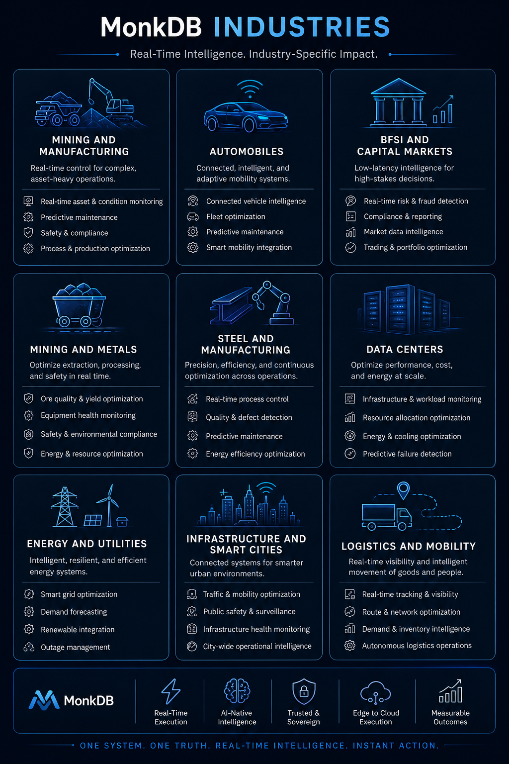

LEARN

Section Header
Learn. Build. Execute.
Subtext
Everything you need to understand, evaluate, and build with MonkDB—across concepts, code, and real-world use.

1. Resources

Crisp Line
Explore MonkDB in action.

Overview
Access demos, videos, and real-world walkthroughs to understand how MonkDB works across use cases and industries.

What to Provide (Important)
This should be your experience layer:
- 🎥 Product demo videos (short + deep dive)
- 🎬 Use case walkthroughs (SmartMine, SmartTrade, etc.)
- 🧪 Interactive demo / sandbox (if possible later)
- 📊 Architecture explainers (visual videos)
- 📁 Solution decks (downloadable PDFs)
- 🎤 Webinars / recorded sessions

Explore More (Website Content)
Resources are designed to help you quickly understand how MonkDB operates in real-world scenarios. From product demos to deep technical walkthroughs, this section gives you a practical view of how data, AI, and execution come together in a single system.

2. Documentation

Crisp Line
Build faster with complete technical guidance.

Overview
Comprehensive documentation to help developers and architects design, build, and deploy systems on MonkDB.

What to Provide (Critical Section)
This is your developer backbone:
- 📘 Getting Started Guide
- ⚙️ Installation & Deployment (Cloud / On-Prem / Edge)
- 🔌 APIs (REST, Pgwire)
- 🧠 Query Language (SQL + hybrid queries)
- 📦 SDKs (Python, TypeScript)
- 🗄️ Data Models (multi-model usage)
- 🔄 Streaming & ingestion guide
- 🔐 Security, RBAC, RLS
- 🏗️ Architecture patterns
- 🧪 Sample projects / GitHub repo
- 📊 Performance tuning guide

Explore More (Website Content)
MonkDB documentation provides everything required to move from concept to production. With detailed guides, APIs, and architecture patterns, developers can build real-time, AI-powered systems without managing complex pipelines or multiple tools.

3. Customer Use Cases

Crisp Line
See how enterprises run on MonkDB.

Overview
Real-world implementations showcasing how organizations use MonkDB to solve complex problems and drive measurable outcomes.

What to Provide
This is your credibility engine:
- 📍 Industry-wise case studies
- 📊 Before vs After comparisons
- 📈 Metrics (cost reduction, latency improvement, etc.)
- 🧠 Architecture used
- ⚡ Problem → Solution → Outcome format
- 🎥 Customer testimonials (video if possible)

Explore More (Website Content)
Customer use cases highlight how MonkDB enables real-time intelligence and execution across industries. From operational optimization to autonomous systems, these examples demonstrate measurable impact and scalable outcomes.

4. Blog

Crisp Line
Ideas, insights, and deep thinking.

Overview
Thought leadership, technical insights, and industry perspectives on real-time data, AI, and execution systems.

What to Provide
This is your thought leadership engine:
- 🧠 Whitepapers (AI, Data Sovereignty, Execution Systems)
- ✍️ Technical blogs (architecture, performance, use cases)
- 🔗 LinkedIn article integrations
- 📊 Research insights (your POV, not generic)
- ⚡ “Monk POV” posts (strong opinion pieces)

Explore More (Website Content)
The MonkDB blog goes beyond product updates—offering deep insights into how modern systems are evolving from data processing to real-time execution. It is a space for ideas, innovation, and industry-defining perspectives.

5. Events

Crisp Line
Engage. Learn. Experience MonkDB live.

Overview
Join live sessions, webinars, and industry events to explore MonkDB and engage with experts.

What to Provide
This is your engagement engine:
- 📅 Upcoming webinars
- 🎤 Conference participation
- 🧑‍💻 Workshops / training sessions
- 🎥 Recorded event sessions
- 🤝 Partner / ecosystem events

Explore More (Website Content)
Events bring MonkDB to life through live demos, expert discussions, and hands-on sessions. Whether virtual or in-person, they provide opportunities to explore use cases, ask questions, and engage with the MonkDB ecosystem.

IMPORTANT STRUCTURE (UX GUIDANCE)
For best impact:
👉 Keep each section:
- Top: 1-line crisp
- Below: short overview (2–3 lines)
- Click → Explore More (detailed content)

OPTIONAL ADD (HIGH IMPACT)

Learning Path (Recommended Section)
Add a guided flow:
Start Here → Build → Scale
- Intro to MonkDB
- Architecture basics
- First app build
- Advanced use cases
- Production deployment
👉 This dramatically improves adoption.

🔥 FINAL LINE FOR THIS SECTION
From understanding to execution—everything you need to build with MonkDB starts here.
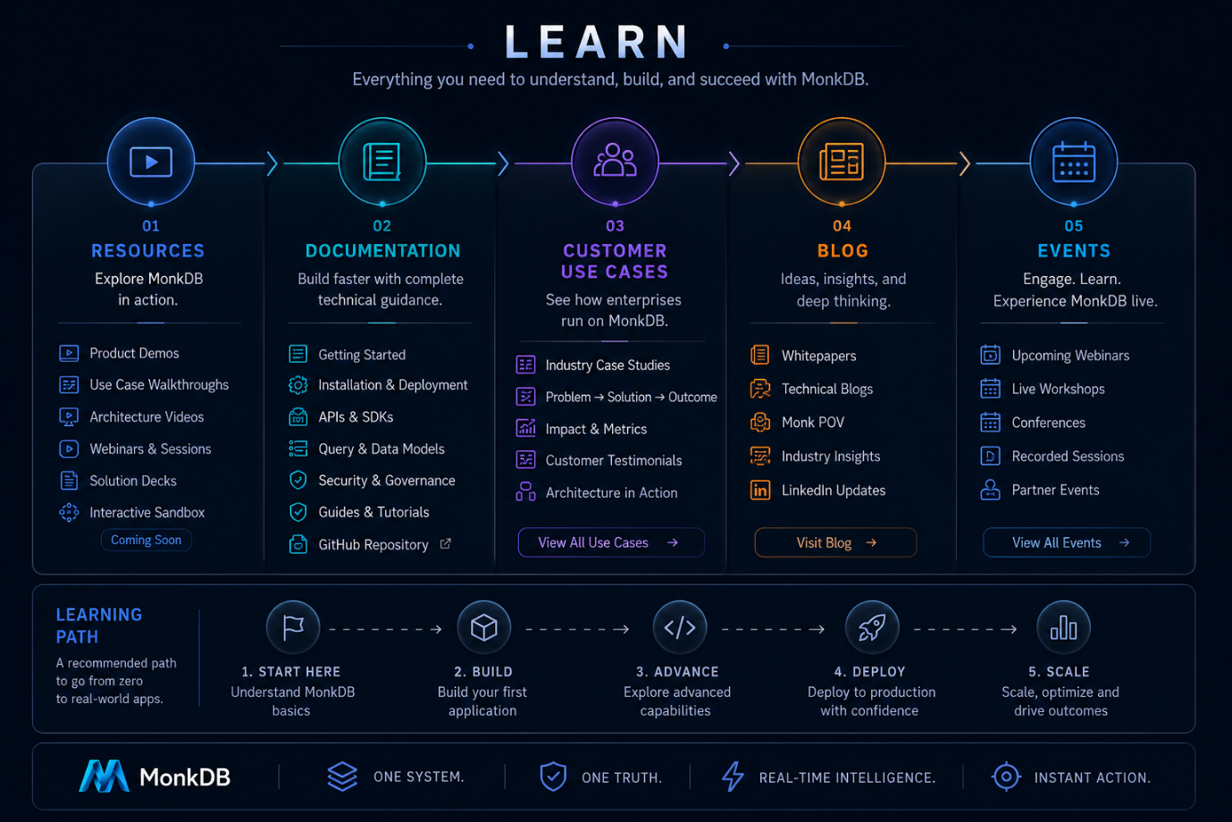

Add the below to developer section or learning / tutorial section.
